Django Project – Code a CRM App Tutorial With Codemy.com

สร้างโปรเจค website

สร้างหน้า Home page

สร้างหน้า base และ navbar

สร้าง login User

สร้าง logout User

สร้าง Form register user

สร้าง Model

Delete Record

Add Record

Update record

python -m venv virt

virt\Scripts\activate

pip install django

django-admin startproject dcrm / cd dcrm

python mange.py startapp website

python manage.py migrate

python manage.py createsuperuser

python manage.py runserver

settings.py

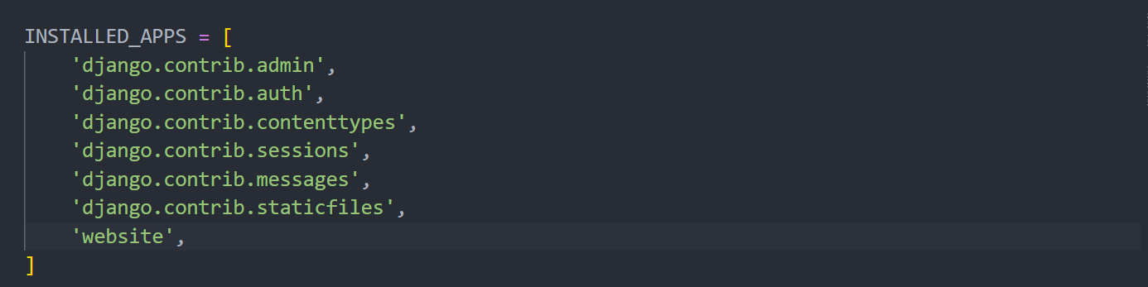

dcrm/urls.py

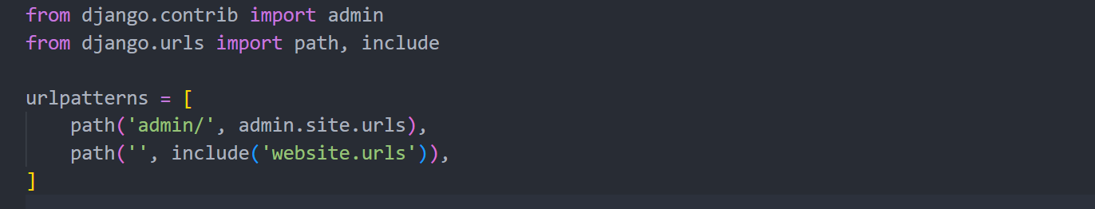

website/urls.py

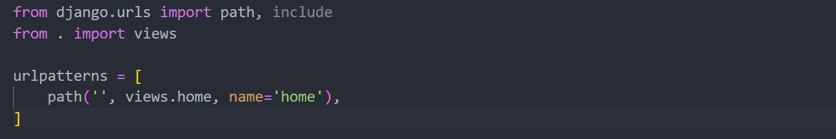

views.py

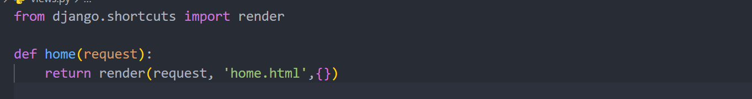

templates/home.html

<h1>Hello World!</h1>

templates/navbar.html >>> bootstrap/navbar

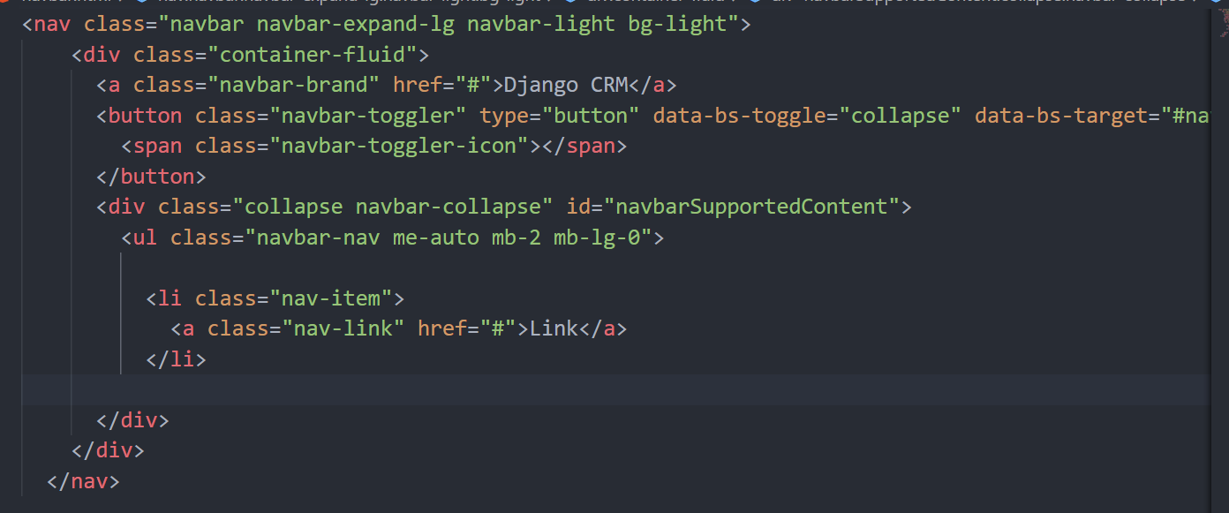

templates/base.html >>>> bootstrap

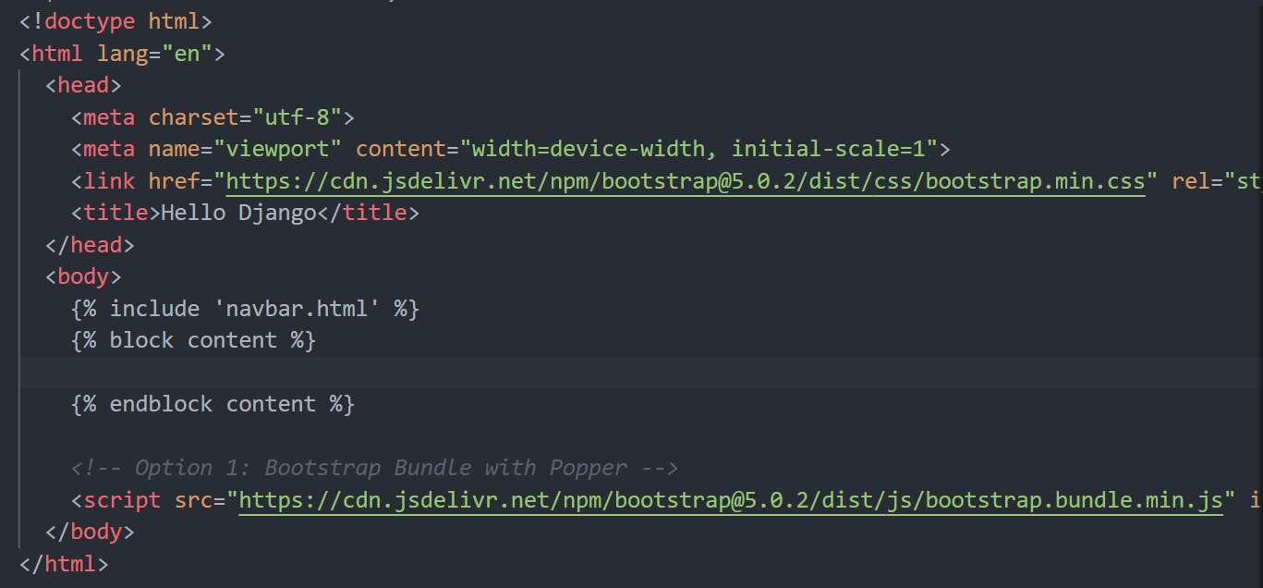

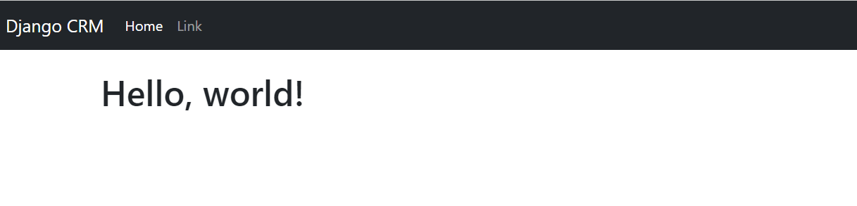

Login User

views.py

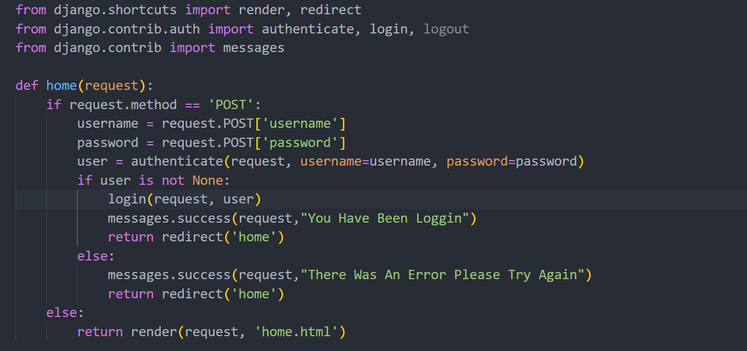

ursls.py

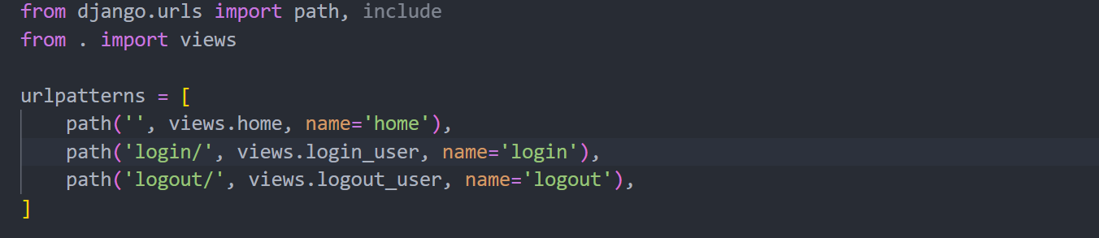

base.html

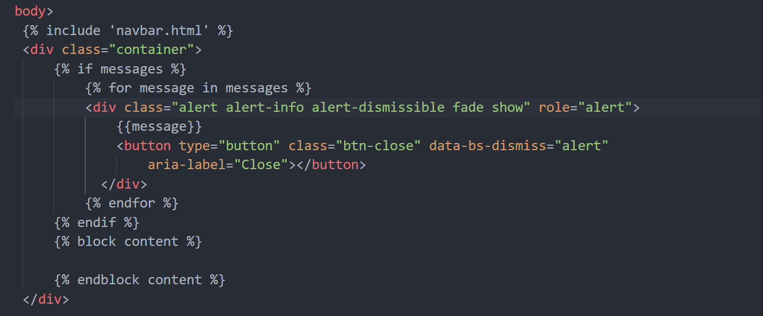

home.html

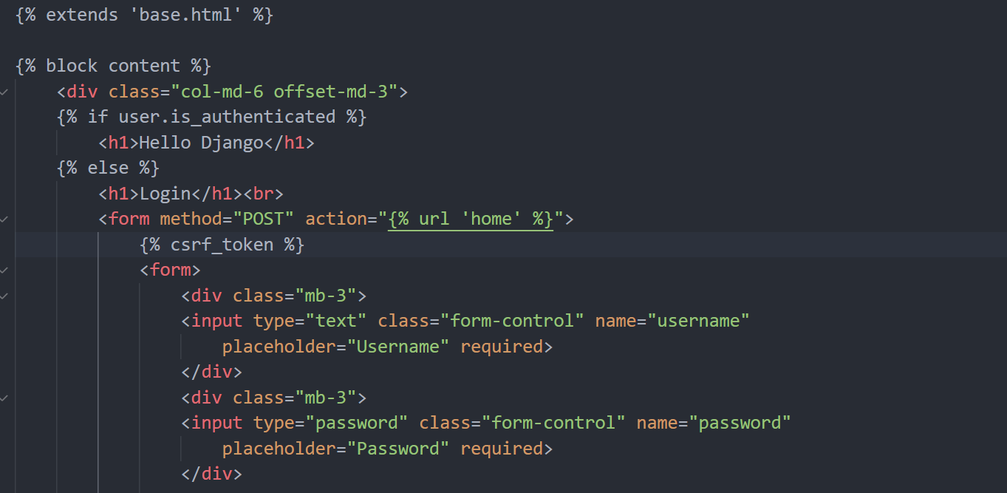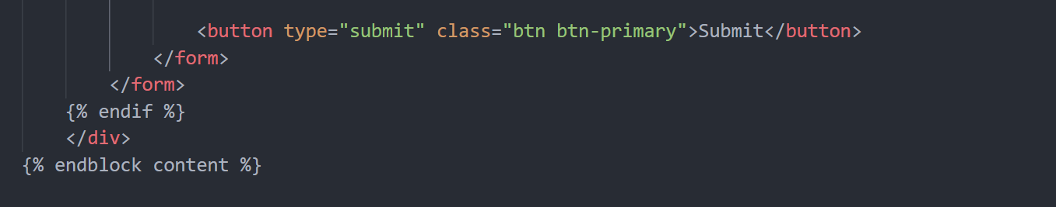

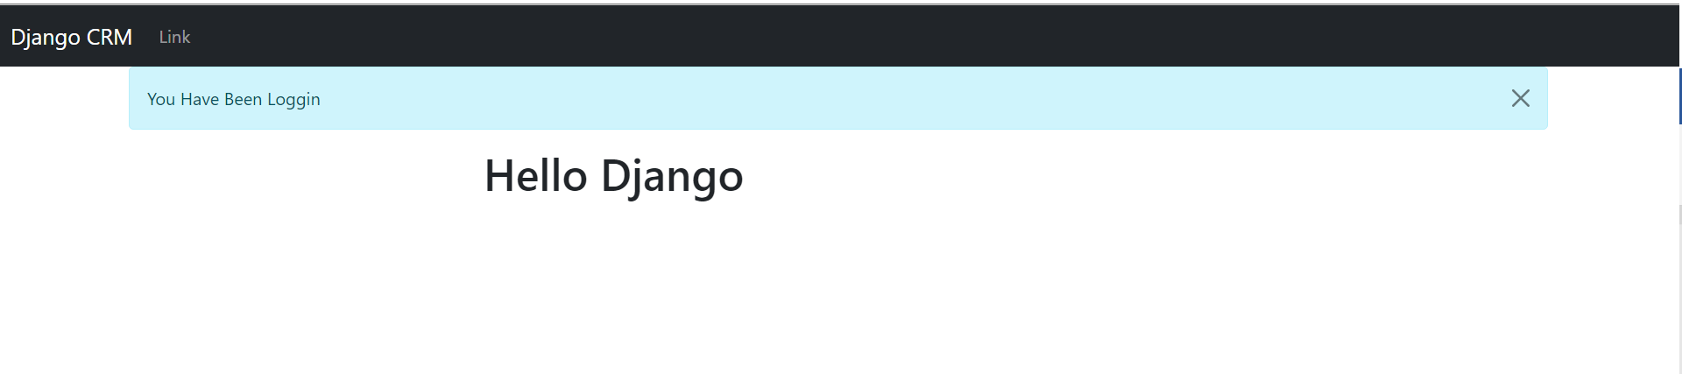

User Logout

views.py

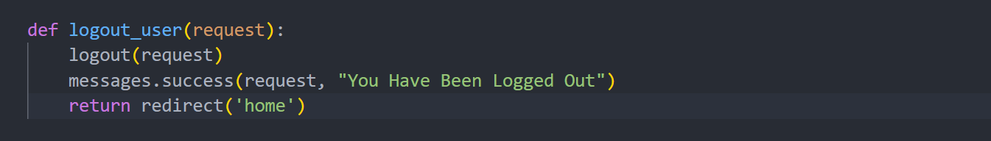

navbar.html

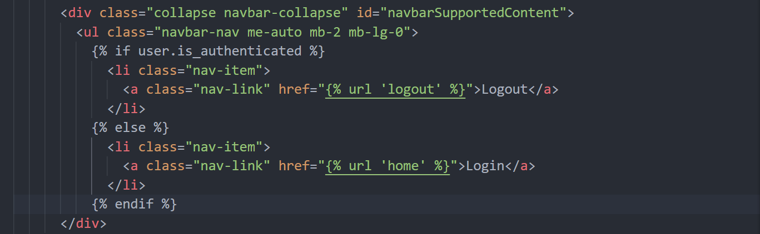

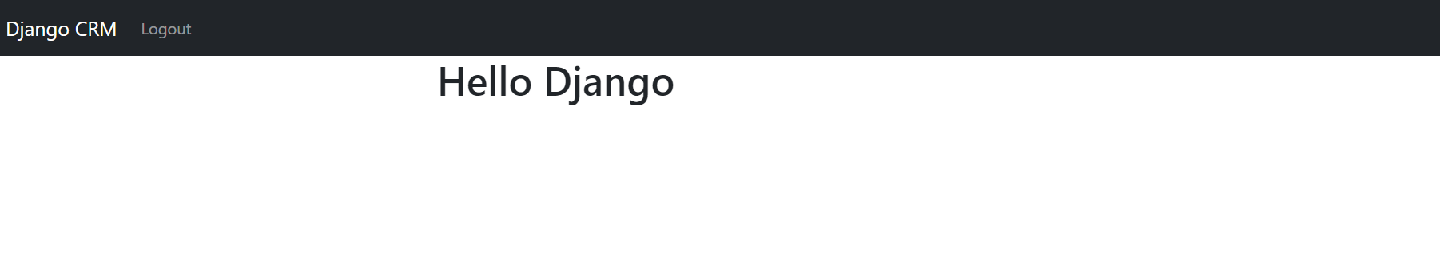

Form Register User https://github.com/flatplanet/Django-CRM

urls.py

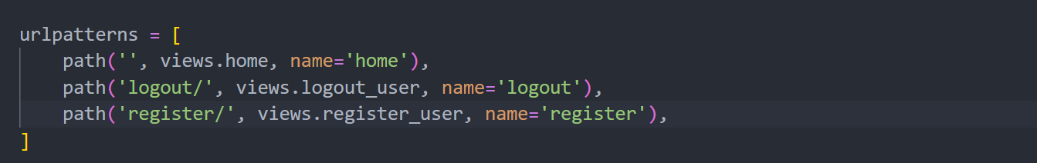

navbar.html

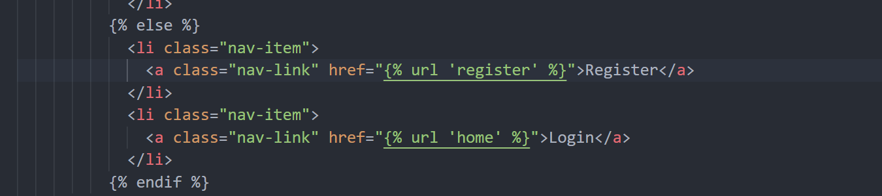

website/forms.py

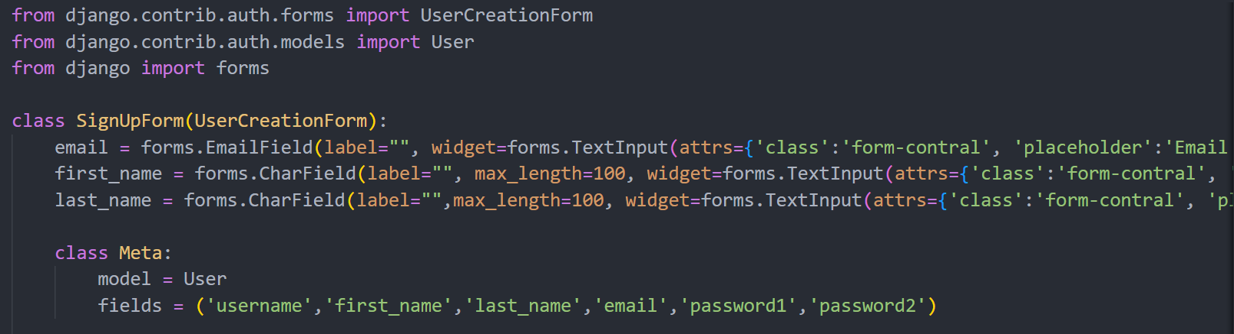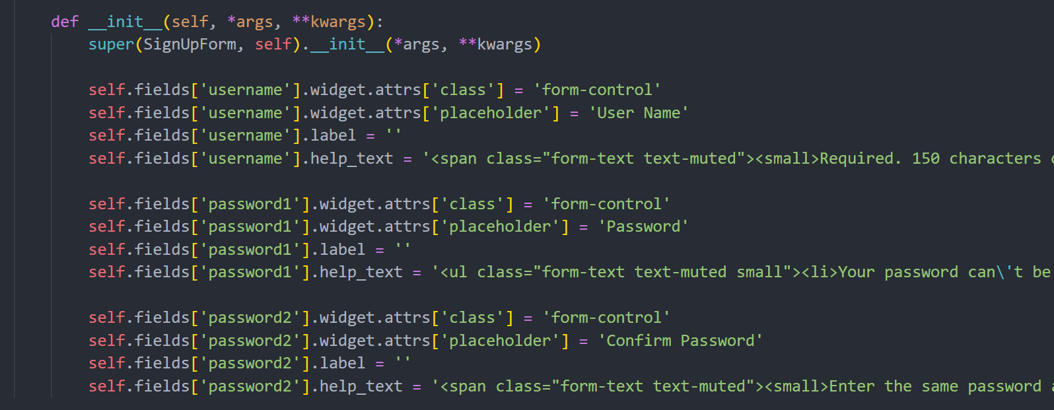

views.py

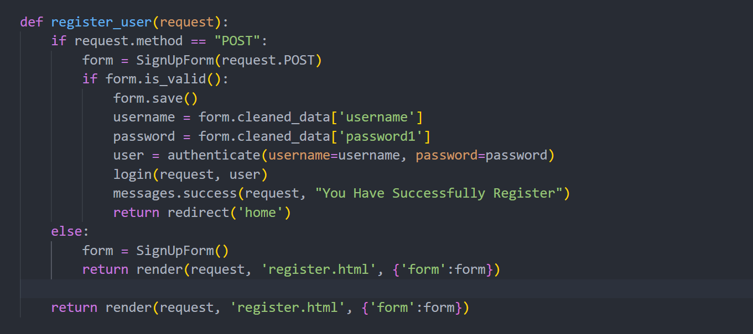

Register.html

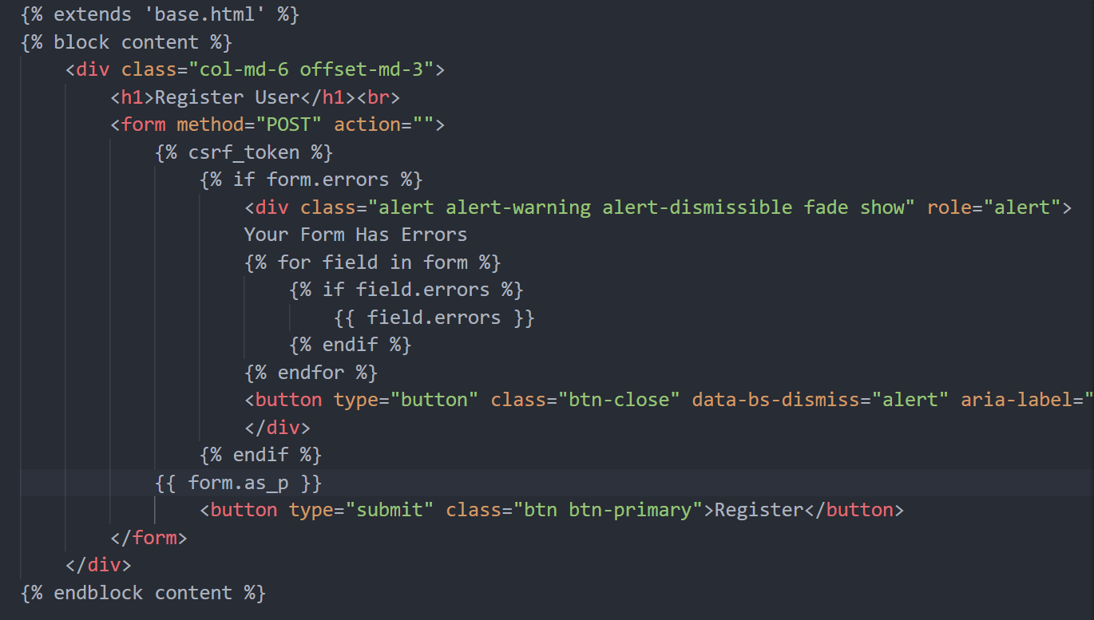

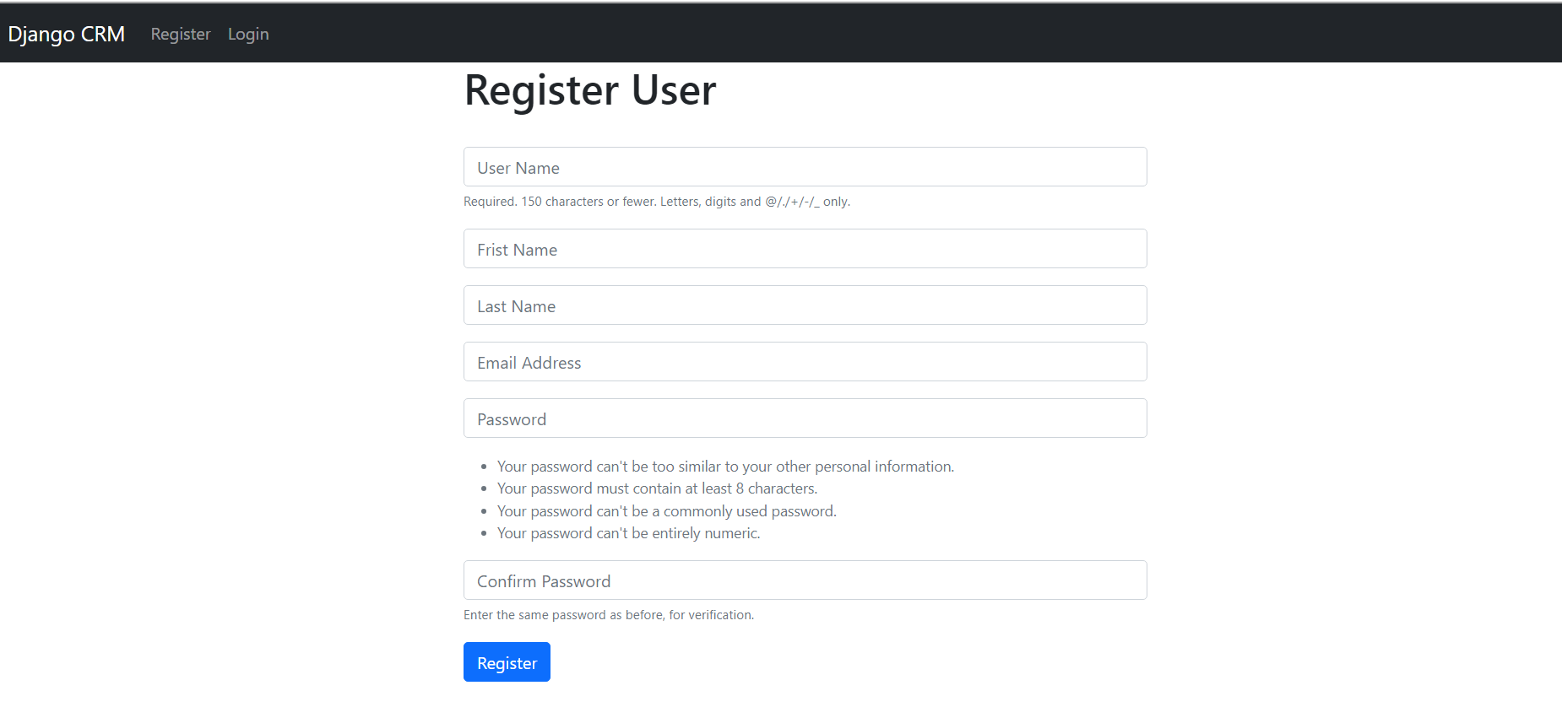

สร้าง Model Database

models.py

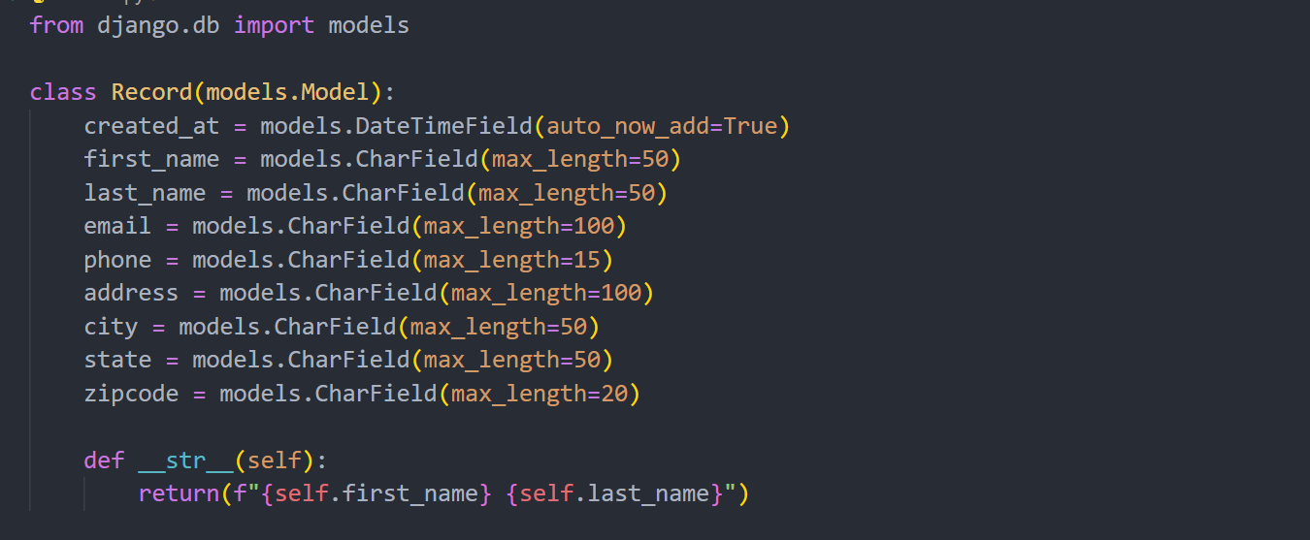

Python mange.py makegrations

Python manage.py migrate

Admin.py

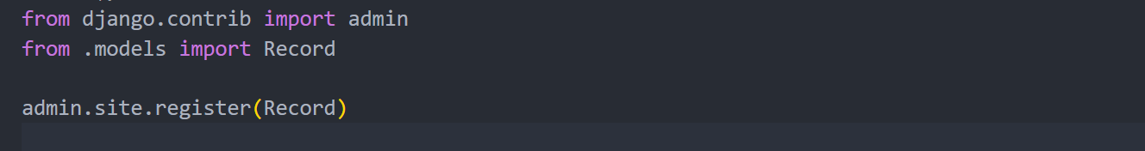

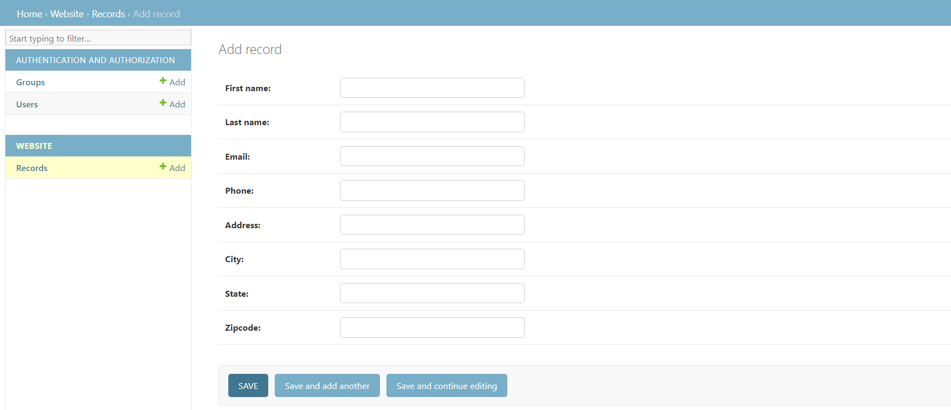

Viesw Record On Website

home.html

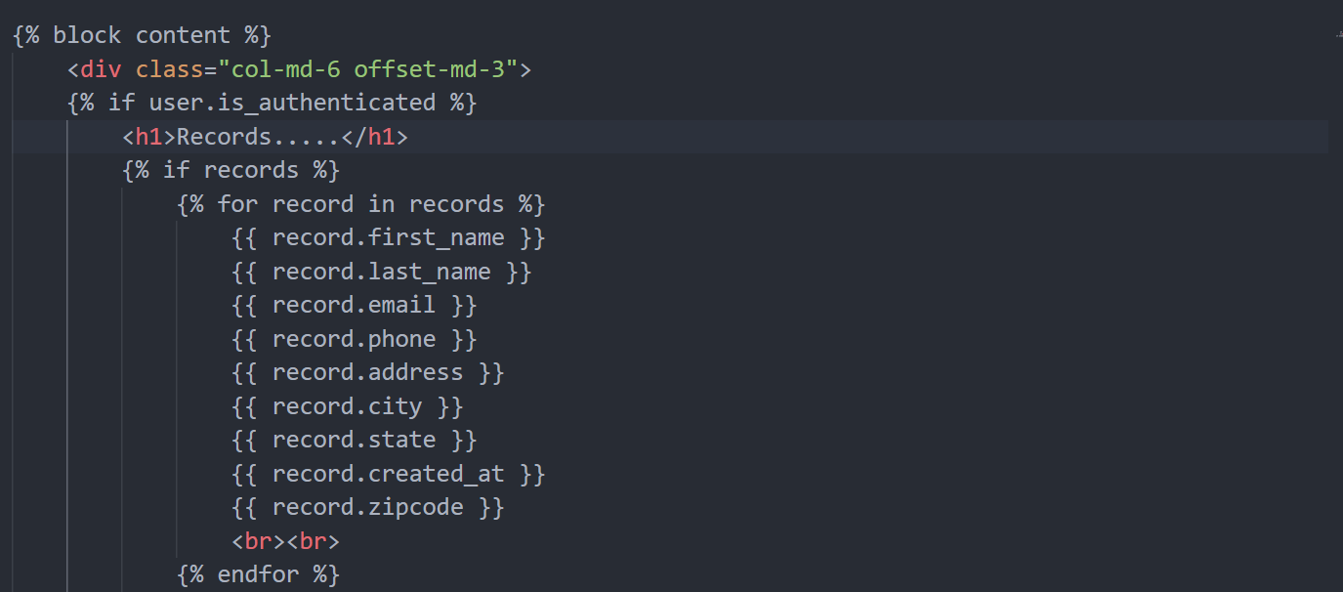

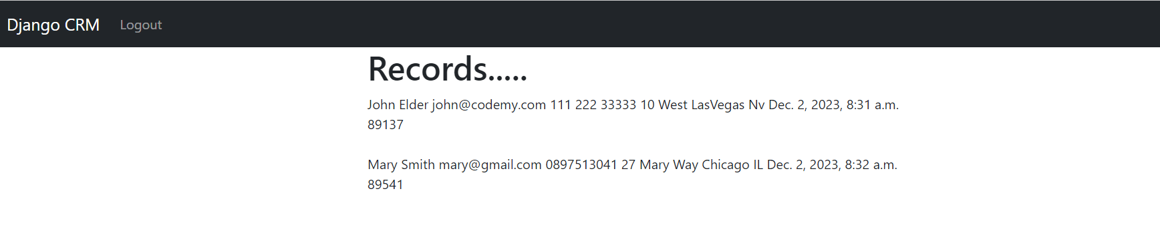

Bootstrap Table

Home.html

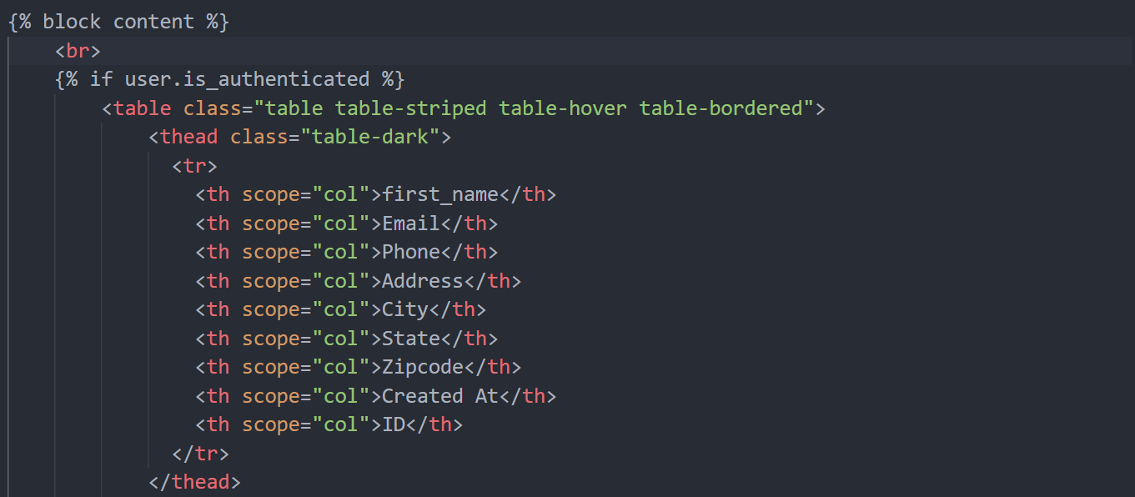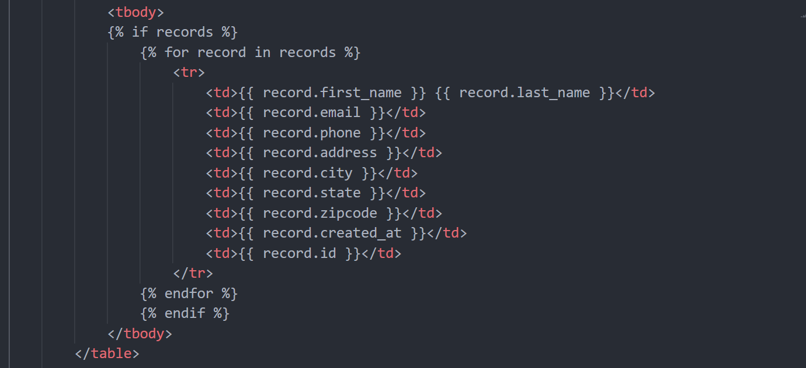

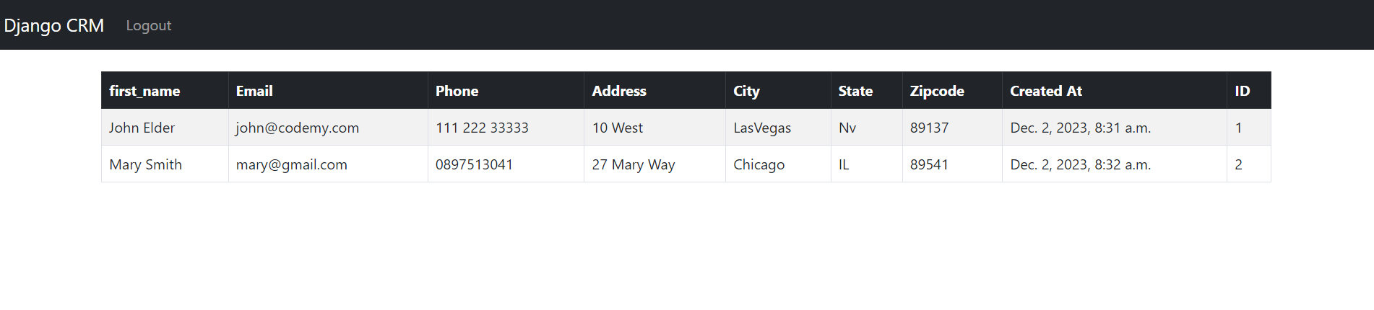

Link record.html

urls.py

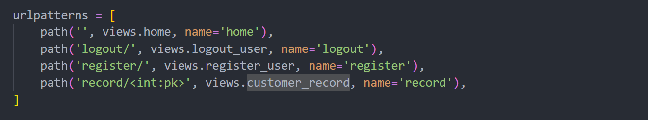

views.py

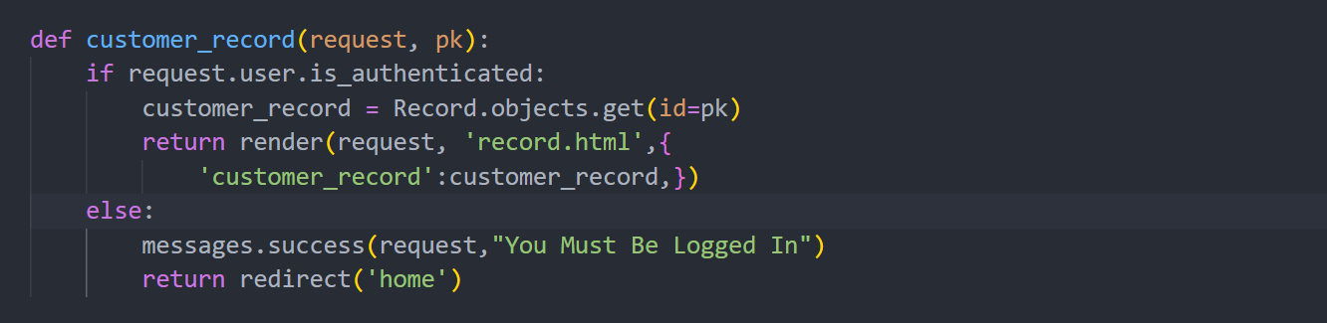

record.html

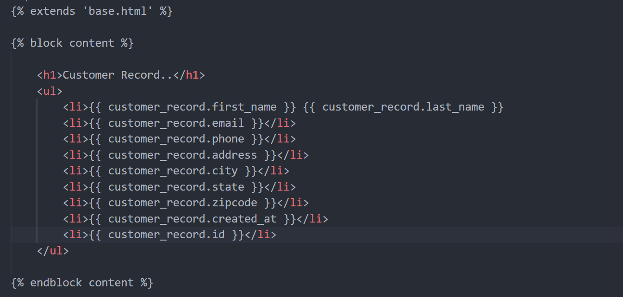

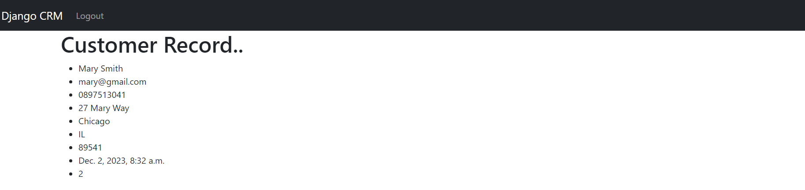

Bootstrap Card

Record.html

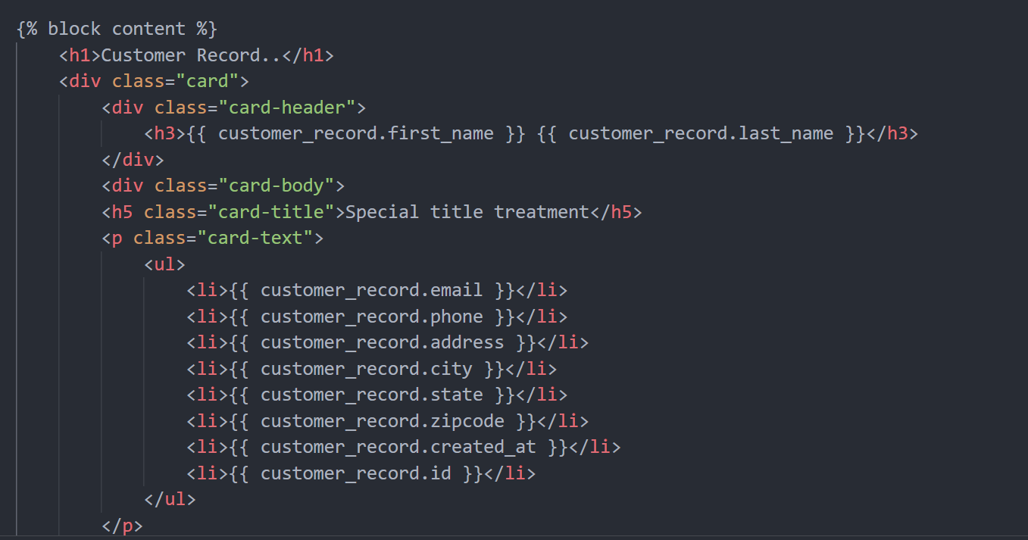

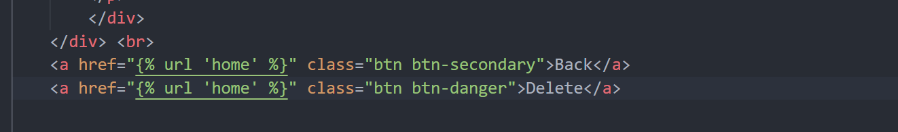

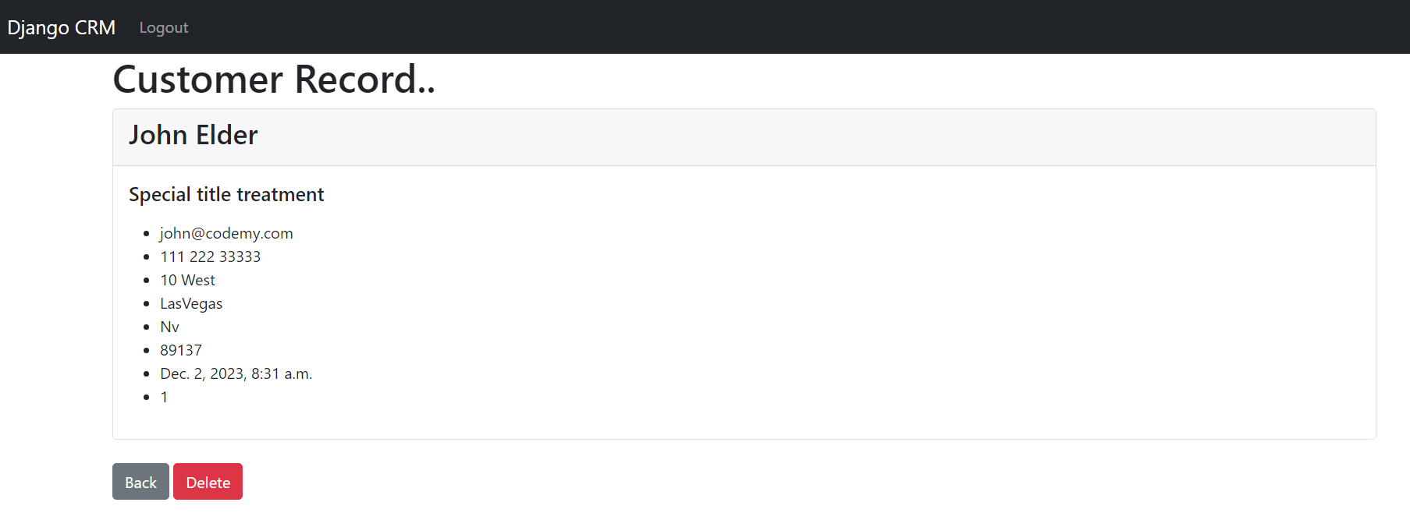

Delete Record

Urls.py

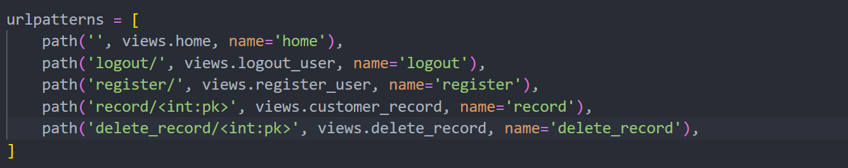

Views.py

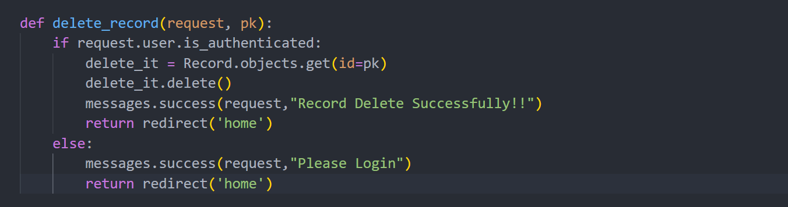

Record.html



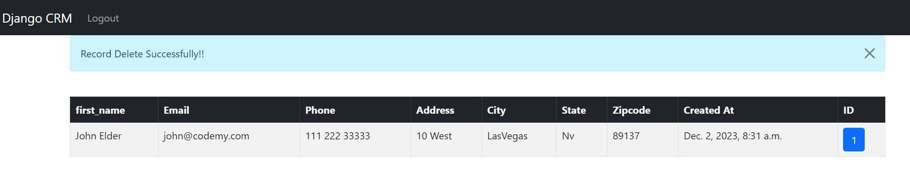

Add Record

Urls.py

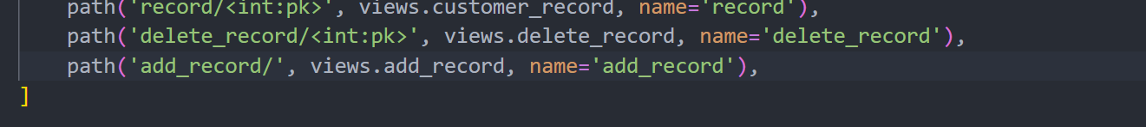

Navbar.html

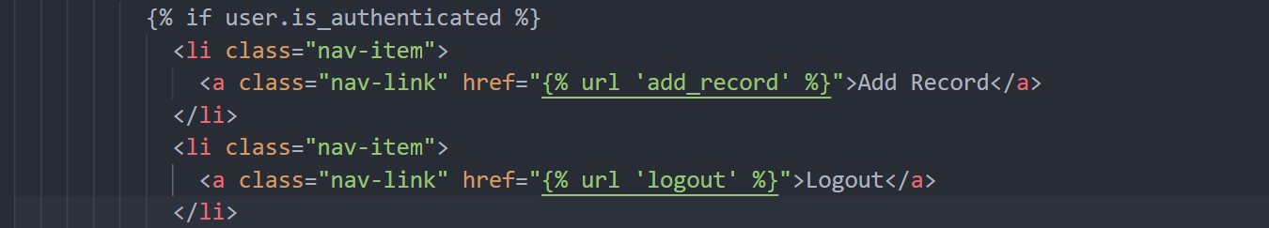

Forms.py

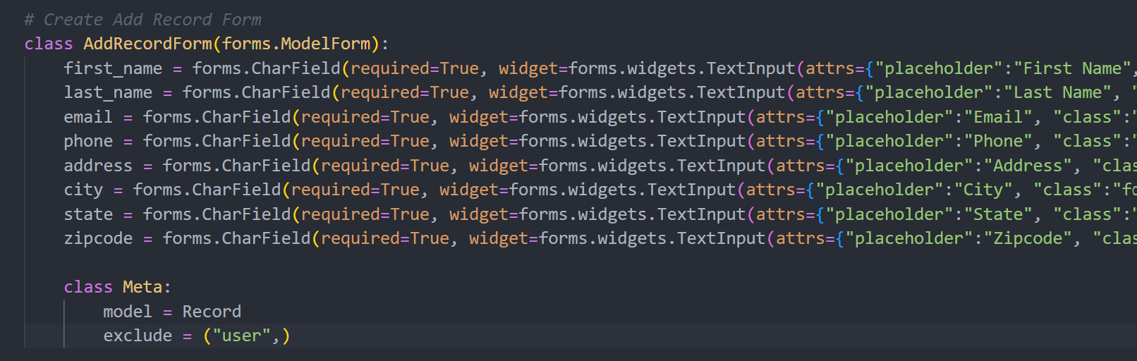

Views.py

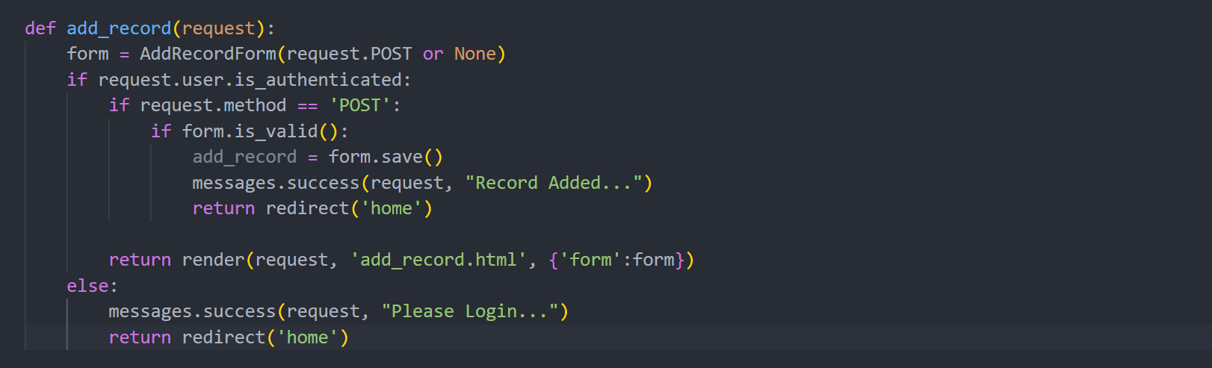

Add_record.html

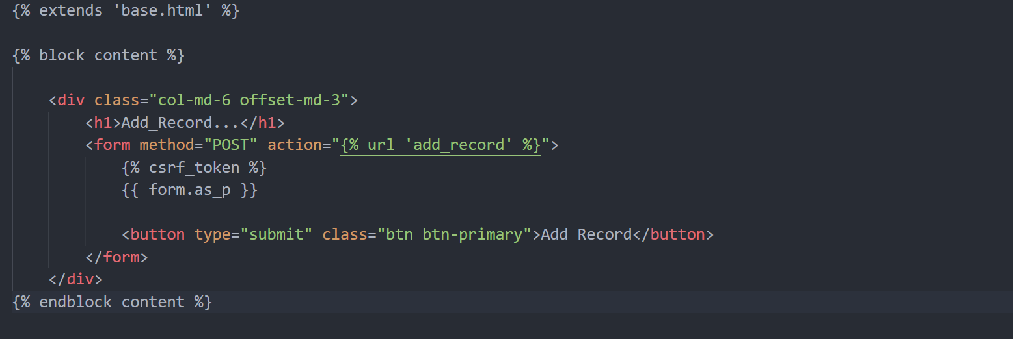

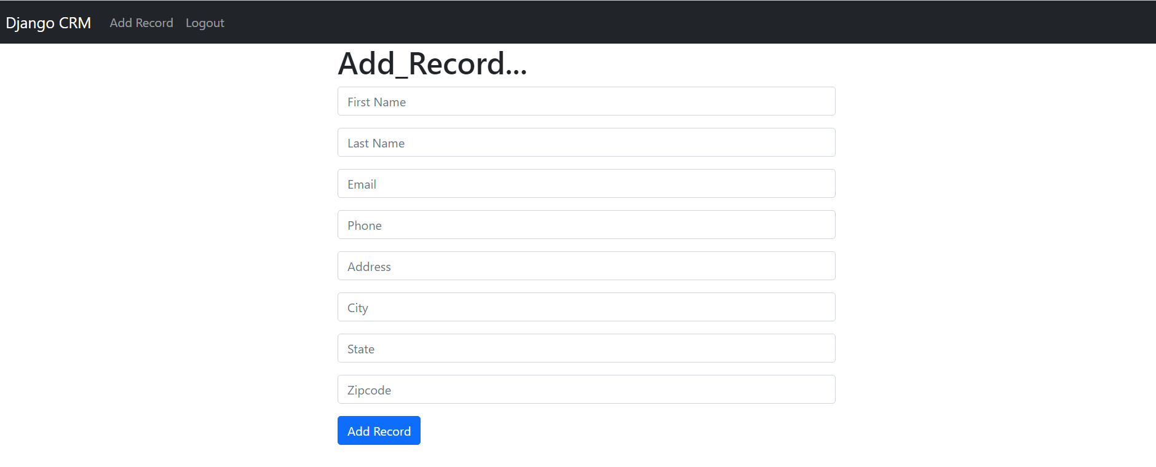

Update Record

Urls.py



Views.py

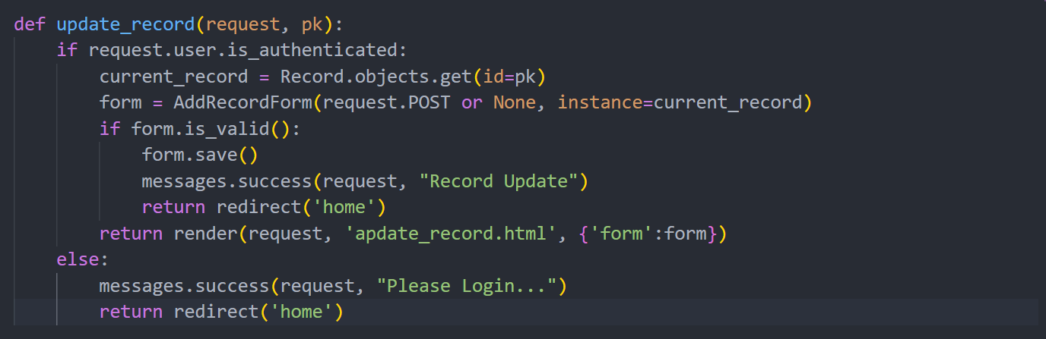

Record.html

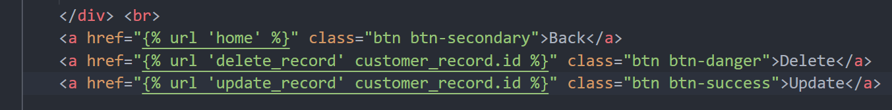

Update_record.html

